JUDUL ARTIKEL DITULIS MAKSIMAL 20 KATA,
DITULIS DALAM BAHASA INDONESIA ← 12 TNR Bold

JUDUL ARTIKEL DITULIS MAKSIMAL 20 KATA,
DITULIS DALAM BAHASA INGGRIS ← 12 TNR Bold Italic

Nama Penulis¹, Nama Penulis² ← 11 TNR Bold
¹²Nama Universitas/Institusi dari Penulis ← 10 TNR
¹²alamat@email.ac.id (alamat email penulis)
¹²Nomer Handpone (WA)

Abstrak
Abstrak dibuat dalam dua bahasa yakni Bahasa Indonesia dan Bahasa Inggris. Abstrak terdiri dari satu paragraf, jumlah kata antara 75 - 250 kata. Abstrak ditulis menggunakan MS-Word Font TNR 10 jarak 1 spasi tidak melebihi 15 lembar dengan format A4-satu kolom. Abstrak harus memuat pendahuluan, metode, hasil dan pembahasan, serta kesimpulan. Kecuali jika artikel berupa kajian atau review dapat disesuaikan. Abstrak tidak memuat uraian matematis dan bahasa statistik, tidak mengandung kutipan, tidak menggunakan singkatan.

Kata Kunci: kata kunci maksimal 5 kata yang mewakili tulisan

Abstract ( bold italic)
Abstract made in two languages namely Indonesian and English. Abstract consisting of one paragraph, the number of words between 75-250 words. Papers be writen by using MS-Word Font TNR 10, italic, single space doesn’t exceed 15 sheets A4-format with one columns. Abstracts should contain an introduction, methods, results and discussion also conclusions. Unless the articles in the form of studies or reviews can be adjusted. Abstract does not contain a description of mathematical and statistical language, it does not contain a quote, do not use abbreviations

Keywords: keyword representing a maximum of 5 words writing

PENDAHULUAN
Bagian pendahuluan berisi latar belakang, kajian literatur yang digunakan sebagai dasar penelitian yang dilakukan, permasalahan penelitian atau hipotesis. Jika artikel berupa kajian atau review cukup menampilkan permasalahan, kerangka kerja analisis, dan sub-sub judul yang dapat disesuaikan dengan isi kajian atau review yang dilakukan. Di bagian akhir pendahuluan dapat pula dituliskan tujuan penulisan artikel.
Pendahuluan ditulis dengan TNR-11 tegak, dengan spasi 1,5. Tiap paragraf diawali kata yang menjorok ke dalam 5 digit, atau sekitar 1 cm dari tepi kiri tiap kolom.

METODE
Pada bagian ini berisi metode, jenis data, sumber data, teknik pengumpulan data, teknik analisis data, pengukuran variabel. Dibuat dalam bentuk paragraf mengalir dan tidak dibuat numbering. Simbol-simbol statistik menggunakan simbol-simbol dan istilah standar misalnya t-test bukan t-hitung.

HASIL DAN PEMBAHASAN
Berisi hasil temuan penelitian di mana antara hasil dan pembahasan tidak dilakukan pemisahan. Harapannya dalam pembahasan ini penulis mengkaji hasil temuannya dan di rujuk silangkan dengan studi teoritik maupun studi empirik, yang ditulis dengan sistematis, analisis yang kritis, dan informatif. Penggunaan tabel, gambar dsb hanya sebagai pendukung yang memperjelas pembahasan dan dibatasi hanya pada pendukung yang benar-benar substantial, misalnya tabel hasil pengujian statistik, gambar hasil pengujian model dan sebagainya. Pembahasan hasil bersifat argumentatif menyangkut relevansi antara hasil, teori, penelitian terdahulu dan fakta empiris yang ditemukan, serta menunjukkan kebaruan temuan. Penggunaan table sangat disarankan tidak terlalu panjang, dan jika memang perlu memasukkan table yang panjang tersebut maka dibuat dalam lampiran.

Contoh penyajian tabel dan gambar

Tabel 1. Judul Tabel
Tahun | Pria | Wanita | Jumlah
2009 | 60 | 28 | 88
2010 | 59 | 30 | 89
2011 | 29 | 16 | 45
2012 | 27 | 20 | 47
2013 | 20 | 17 | 37

Grafik 1. Judul grafik

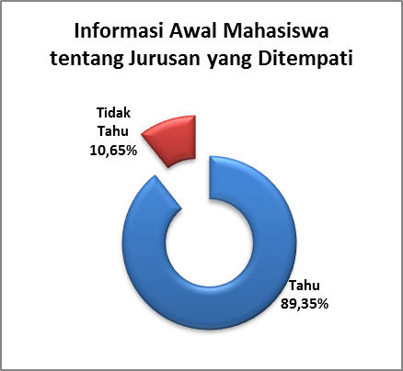

Gambar 1. Judul gambar

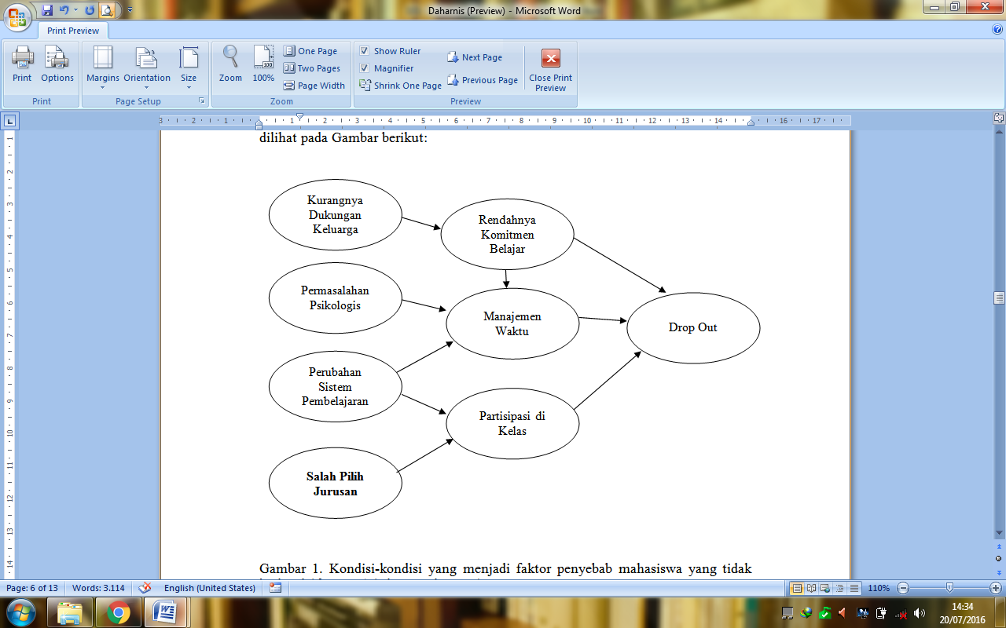

KESIMPULAN
Bagian ini berisi kesimpulan yang ditulis dalam satu atau dua paragraf. Kesimpulan ditulis dalam bentuk esai, tidak dalam bentuk numerikal. Kesimpulan hendaknya merupakan jawaban atas pertanyaan penelitian, dan tidak dijelaskan dalam kalimat statistik. Jika perlu menuliskan saran atau rekomendasi maka dituliskan menyatu dalam paragraph kedua.

DAFTAR PUSTAKA
Daftar pustaka pada Jurnal PRODI ditulis mengikuti format APA (American Psychological Association) 6th Edition. Penulisan Daftar Pustaka sebaiknya menggunakan aplikasi referensi manager seperti Mendeley, End Note, Zotero, atau lainnya. Jumlah referensi yang digunakan dalam artikel minimal 15 buah referensi, yang terdiri dari 80% referensi primer (jurnal) dan 20% referensi lainnya. Referensi yang digunakan 5-10 tahun.

Berikut beberapa contoh penulisan daftar pustaka:

Albert, C., & Garcı´a-Serrano, C. (2010). Cleaning the slate? School choice and educational outcomes in Spain. High Educ, 559–582. http://doi.org/10.1007/s10734-010-9315-9
Brown, S. D., & Lent, R. W. (2013). Career Development and Counseling: Putting Theory and Research to Work. (2, Ed.)John Wiley & Sons (2nd ed., Vol. 53). New Jersey: John Wiley & Sons. http://doi.org/10.1017/CBO9781107415324.004
Heppner, P. P., Wampold, B. E., & Kivlighan, D. M. (2008). Research Design in Counseling, Third Edition. Belmont: Thomson Higher Education.

APA FORMAT–6 ^{TH} EDITION

JOURNALS, MAGAZINES, NEWSPAPERS IN PRINT FORMAT General Form
Author, A. A., Author, B. B., & Author, C. C. (Year). Title of article. Title of Journal, xx, xxx-xxx.

NOTE: The journal title and the volume number are in italics. Issue numbers are not required if the journal is continuously paged. If paged individually, the issue number is required and is in regular type in parentheses adjacent to the volume number.

One Author
Williams, J. H. (2008). Employee engagement: Improving participation in safety. Professional Safety, 53(12), 40-45.

Two to Seven Authors [List all authors]
Keller, T. E., Cusick, G. R., & Courtney, M. E. (2007). Approaching the transition to adulthood: Distinctive profiles of adolescents aging out of the child welfare system. Social Services Review, 81, 453-484.

Eight or More Authors [List the first six authors, … and the last author]
Wolchik, S. A., West, S. G., Sandler, I. N., Tein, J.-Y., Coatsworth, D., Lengua, L.,...Griffin, W. A. (2000). An experimental evaluation of theory-based mother and mother-child programs for children of divorce. Journal of Consulting and Clinical Psychology, 68, 843-856.

Magazine Article
Mathews, J., Berrett, D., & Brillman, D. (2005, May 16). Other winning equations. Newsweek, 145(20), 58-59.

Newspaper Article with No Author and Discontinuous Pages
Generic Prozac debuts. (2001, August 3). The Washington Post, pp. E1, E4.

BOOKS, CHAPTERS IN BOOKS, REPORTS, ETC. General Form
Author, A. A. (Year). Title of work. Location: Publisher.

One Author
Alexie, S. (1992). The business of fancydancing: Stories and poems. Brooklyn, NY: Hang Loose Press.

Corporate Author with an Edition and Published by the Corporate Author
American Psychiatric Association. (1994). Diagnostic and statistical manual of mental disorders (4th ed.). Washington, DC: Author.

Anonymous Author
Dorland’s illustrated medical dictionary (31st ed.). (2007). Philadelphia, PA: Saunders.

Chapter in a Book
Booth-LaForce, C., & Kerns, K. A. (2009). Child-parent attachment relationships, peer relationships, and peer-group functioning. In K. H. Rubin, W. M. Bukowski, & B. Laursen (Eds.), Handbook of peer interactions, relationships, and groups (pp. 490-507). New York, NY: Guilford Press.

ERIC Document
Shyyan, V., Thurlow, M., & Liu, K. (2005). Student perceptions of instructional strategies: Voices of English language learners with disabilities. Minneapolis, MN: National Center on Educational Outcomes, University of Minnesota. Retrieved from the ERIC database.(ED495903)

ONLINE JOURNALS, MAGAZINES, NEWSPAPERS General Format – Databases
Author, A. A., Author, B. B., & Author, C. C. (Year). Title of article. Name of Journal, xx, xxx-xxx. doi:xxxxxxxxxx

Article Retrieved from an Online Database
NOTE: Use the article’s DOI (Digital Object Identifier), the unique code given by the publisher to a specific article.

Senior, B., & Swailes, S. (2007). Inside management teams: Developing a teamwork survey instrument. British Journal of Management, 18, 138-
153. doi:10.1111/j.1467-8551.2006.00507.x

NOTE: Use the journal’s home page URL (or web address) if there is no DOI. This may require a web search to locate the journal’s home page. There is no period at the end of web address. Break a long URL before the punctuation.

Koo, D. J., Chitwoode, D. D., & Sanchez, J. (2008). Violent victimization and the routine activities/lifestyle of active drug users. Journal of Drug Issues, 38, 1105-1137. Retrieved from http://www2.criminology.fsu.edu/~jdi/

Article from an Online Magazine
Lodewijkx, H. F. M. (2001, May 23). Individual-group continuity in cooperation and competition under varying communication conditions. Current Issues in Social Psychology, 6(12), 166-182. Retrieved from http://www.uiowa.edu/~grpproc/crisp/crisp.6.12.htm

OTHER ONLINE RESOURCES General Form
Author, A. A. (Year). Title of work. Retrieved from web address

Online Report from a Nongovernmental Organization
Kenney, G. M., Cook, A., & Pelletier, J. (2009). Prospects for reducing uninsured rates among children: How much can premium assistance programs help? Retrieved from Urban Institute website: http:// www.urban.org/url.cfm?ID=411823

Online Report with No Author Identified and No Date
GVU's 10th WWW user survey. (n.d.). Retrieved from http://www.cc.gatech.edu/user_surveys/survey-1998-10/

Web Sites in Parenthetical Citations: To cite an entire Web site (but not a specific document within the site), it is sufficient to give the URL of the site in the text. No entry in the reference list is needed. Example:

Kidpsych is an excellent website for young children (http://
www.kidpsych.org).

REFERENCE CITATIONS IN TEXT

APA utilizes a system of brief referencing in the text of a paper, whether one is paraphrasing or providing a direct quotation from another author’s work. Citations in the text usually consist of the name of the author(s) and the year of publication. The page number is added when utilizing a direct quotation.

Indirect Quotation with Parenthetical Citation
Libraries historically highly value intellectual freedom and patron confidentiality (LaRue, 2007).

Indirect Quotation with Author as Part of the Narrative
LaRue (2007) identified intellectual freedom and patron confidentiality as two key values held historically by libraries.

Direct Quotation with Parenthetical Citation
Darwin used the metaphor of the tree of life "to express the other form of interconnectedness–genealogical rather than ecological" (Gould & Brown, 1991, p. 14).

Direct Quotation with Author as Part of the Narrative
Gould and Brown (1991) explained that Darwin used the metaphor of the tree of life "to express the other form of interconnectedness– genealogical rather than ecological”(p. 14).

CITING SECONDARY SOURCES

When citing in the text a work discussed in a secondary source, give both the primary and the secondary sources. In the example below, the study by Seidenberg and McClelland was mentioned in an article by Coltheart, Curtis, Atkins, & Haller.

Seidenberg and McClelland’s study (as cited in Coltheart, Curtis, Atkins, & Haller, 1993) provided a glimpse into the world

In the references page, you would cite the secondary source you read not the original study.

Coltheart, M., Curtis, B., Atkins, P., & Haller, M. (1993). Models of reading aloud: Dual-route and parallel-distributed- processing approaches. Psychological Review, 100, 589-608.

